**AMITY UNIVERSITY**

**SOURCE CODE MANAGEMENT**

**Name: Asgar Pasha**

**Course: Source code management**

**School: ASET B. tech CSE**

**Assignment: Lab manual**

**Course instructor: Monith Kapoor**

**Date: 05-06-2025**

* **The command pwd stands for "print working directory" to display the absolute path of the current directory you are in**

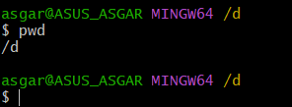

* **ls, which is short for "list" and is used to display the contents of a directory**

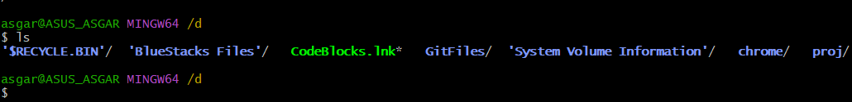

* **changing directory**

**now we have changed our location form c to d drive**

* **The mkdir command stands for "make directory" and is used to create new folders (directories) in your file system**

* **“vi”  used to create, view, and edit text files directly from the terminal.**

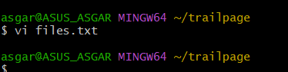

* **This is how the terminal looks like**

* **Now we have to initialize an empty git repo in our local device.**

* **Now adding the file into it**
* **Also we will use the command “git status” to check the status of the file.**

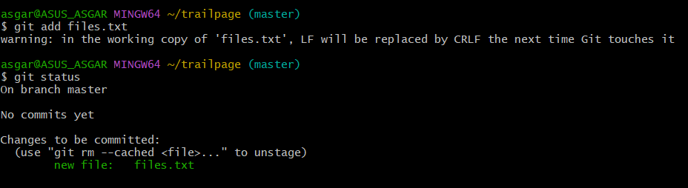

**INTRODUCTION-GITBASH**

**Step1: Search Git in your browser and click on the first link ‘Git’**

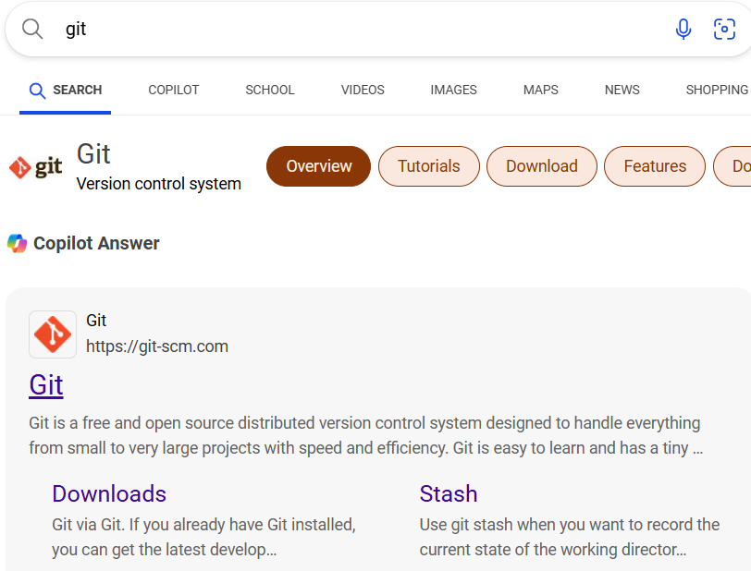



**Step2: Click on ‘Download for windows’**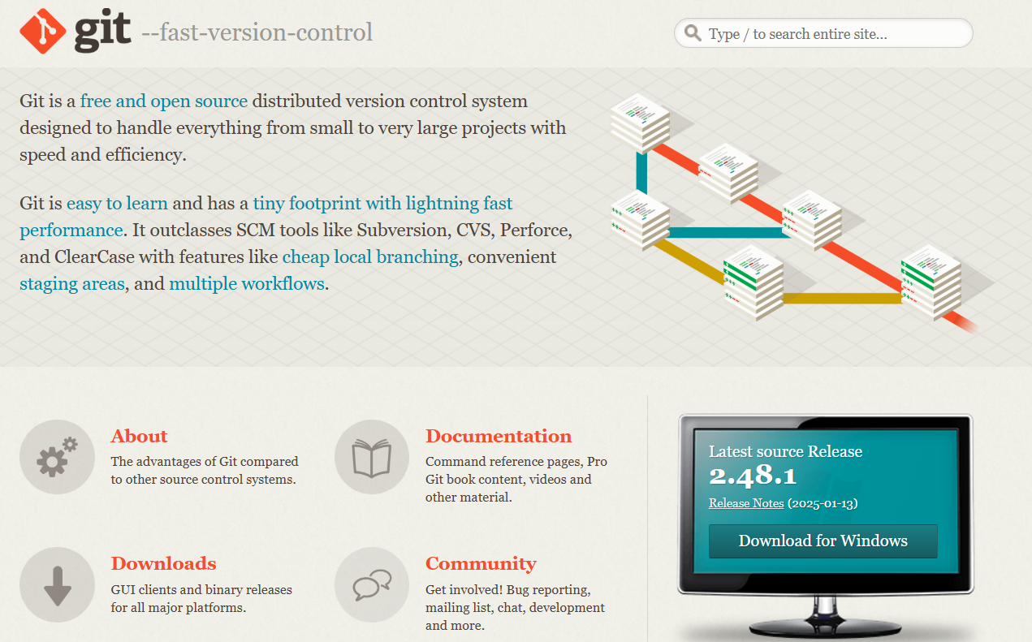



**Step3: Download git (according to your device specifications) click on ’64-bit Git foe windows setup’**

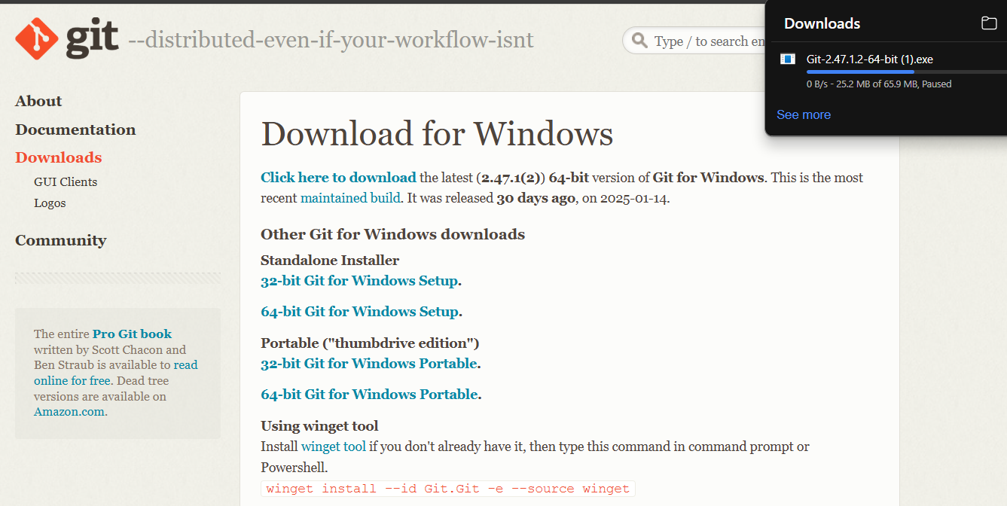

**Step4: Open git from files and click on Next**

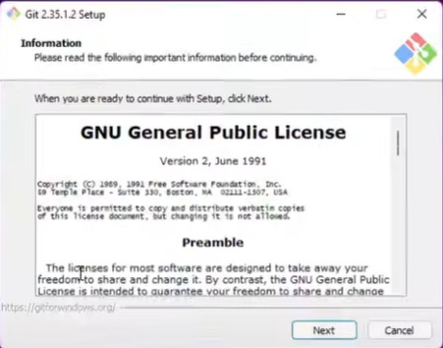

**Step5: click next**

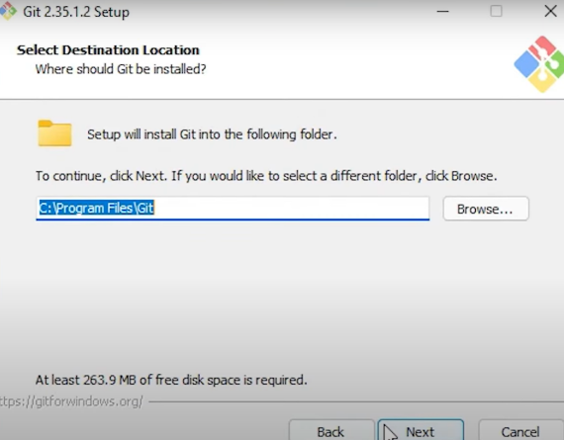

**Step6: click next**

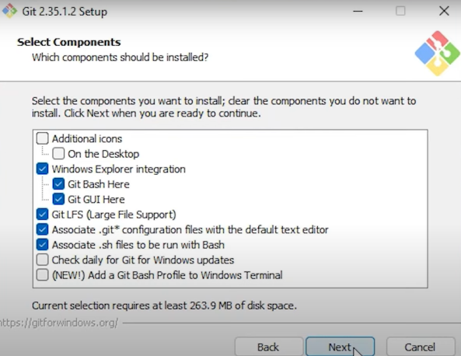

**Step7: Click next**

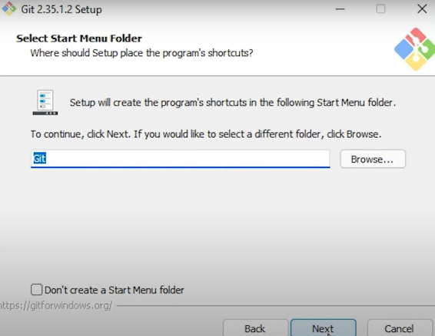

**Step8: click next**

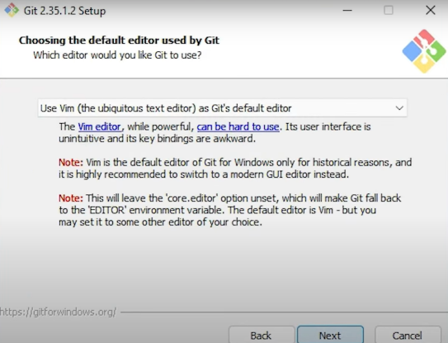

**Step9: Click next**

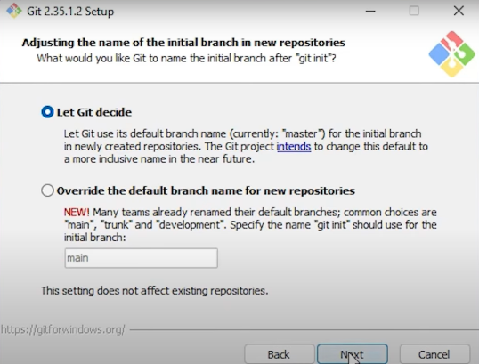

**Step10: Click next**

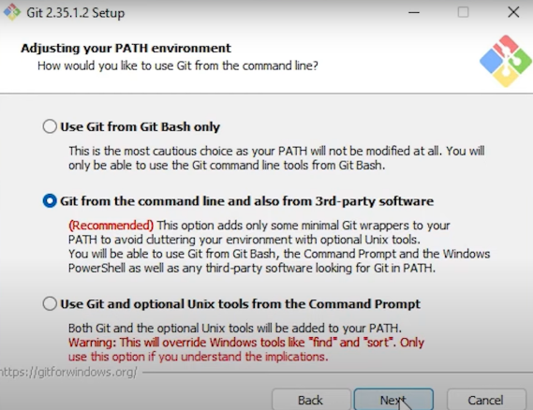

**Step11: Click next**

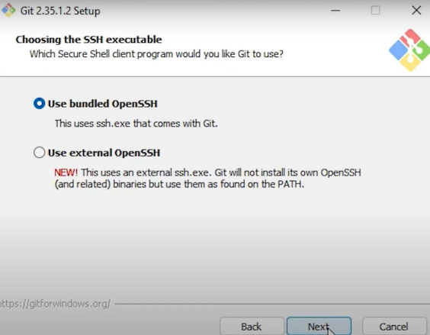

**Step12: Click next**

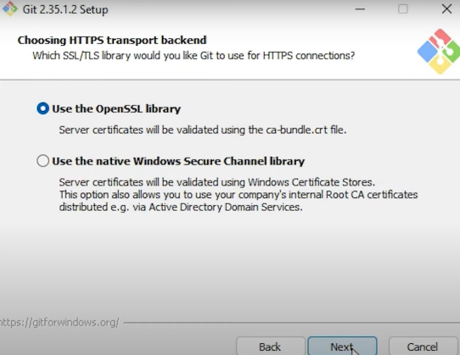

**Step13: Click next**

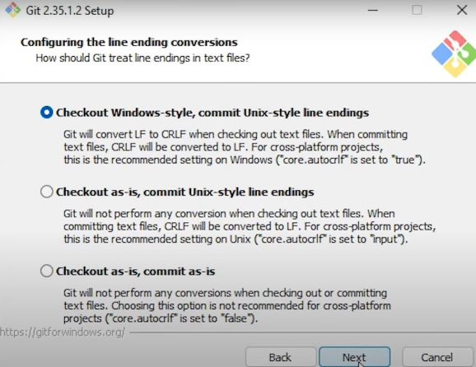

**Step14: Click next**

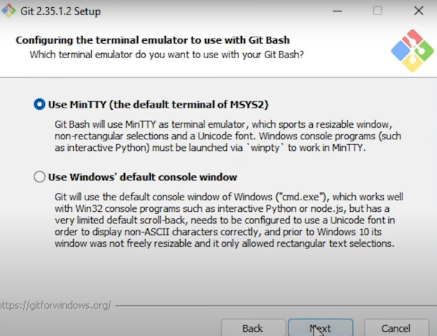

**Step15: Click next**

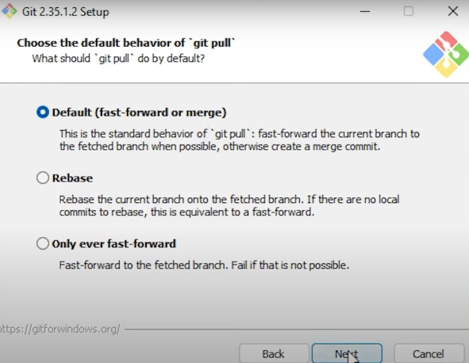

**Step16: Click next**

**Step17: Click next**

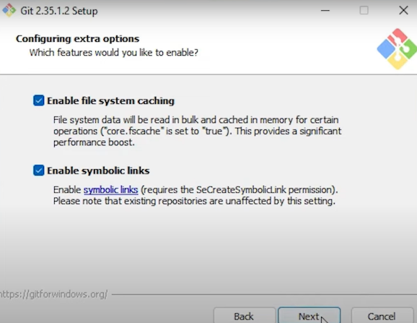

**Stpe18: Click Install**

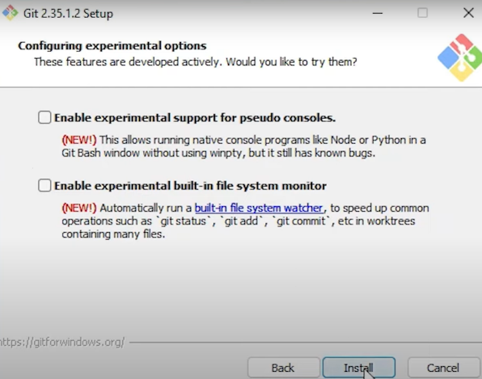

**Installing**

**Step19: Select ‘Launch Git Bash’ and click ‘Finish’**

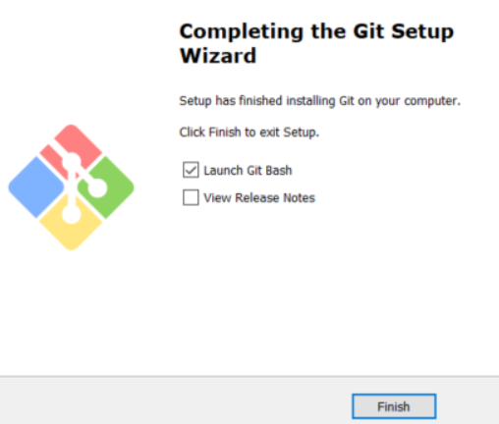

**Step20: Interface**

**EXPERIMENT 3: GITBASH AND GITHUB**

* **Terminal of gitbash**

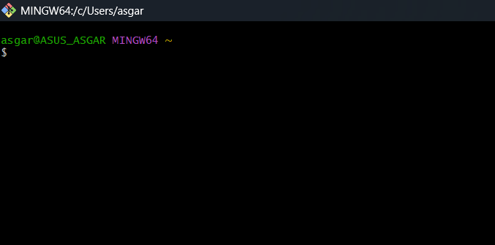

* **This is the terminal where we use our linux commands to create, red, edit, add, commit, and push our files into github.**

**Github interface**

**To the left top corner we see a “+” symbol, from there we can create a repository in github. To this repo only we will add our files and projects from git bash**

* **Connecting our local repository to github repositories.**

* **We use “git remote add origin <repo_url>” to connect our local repo to github repo.**

**FILE CREATION WITH COMMIT AND PUSH COMMAND.**

* **we will first open our directory and create a local repo.**
* **Mkdir(make directory) to create a local folder.**
* **Then use cd(change directory command) and get into it.**
* 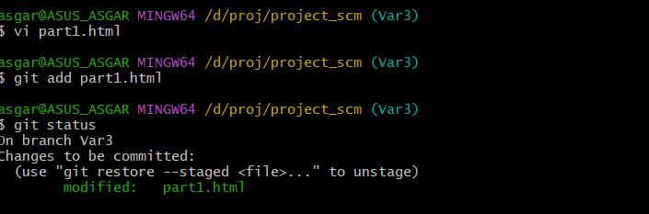**“vi” is used to create a file in the folder that we have created.**
* **In this terminal we will include all the info that needs to be put into the file.A black screen with a black background

  AI-generated content may be incorrect.**

* **Git init is used to initialize an empty git repo**
* **After creating and writing into the file we will add it to empty repo using “git add “file_name” command.**
* **Then we will check the status of the file using “git status” command.**

* **After adding the file we will add a commit using “git commit -m “comment” command.**

* **Now we will connect our local repo with our github using “git remote add origin “repo-url” command.**

* **Now we will push our files into github repo using “ git push -u origin “branch_name” command.**

**BRANCH CREATION**

* **To create a new branch using git we will use the command**

**# git branch “new branch name”**

* **To move from one branch to another we use**

**# git switch/checkout “branch_name”**

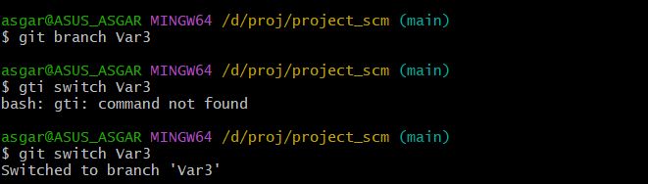

* **To check number of branches we use**

**# git branch command**

**MERGE REQUEST**

* **For using merge we will first get into the branch to which we have to merge the other branch**

****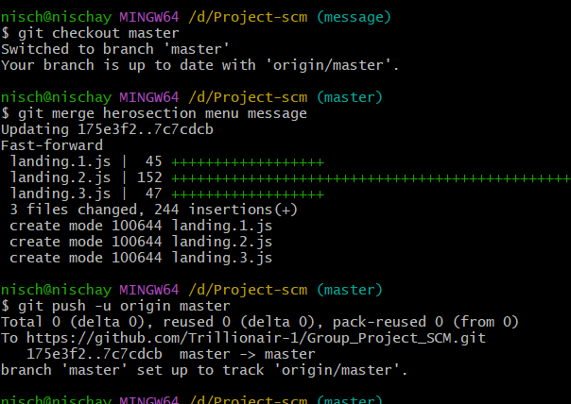

* **Then use the command “git merger <branch_name>”. Enter the name of the branch that needs to be merged to the master branch.**
* **Then use git push command to complete the merge request.**

**OPEN AND CLOSE PULL REQUEST**

* **Search for the repo for which you need to send pull request on github**

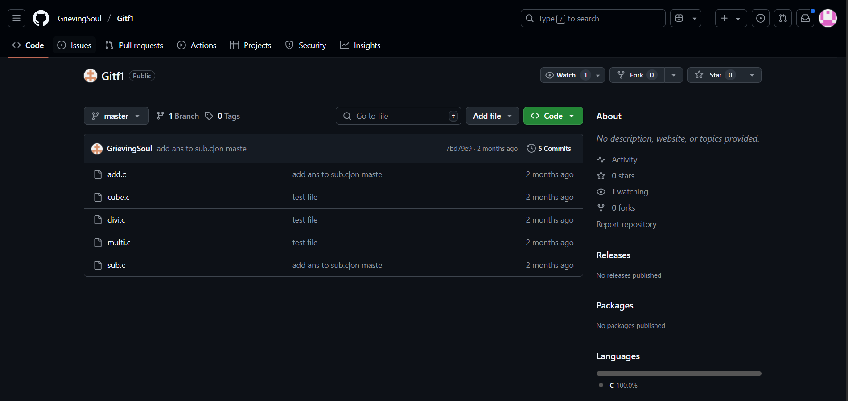

* **Then look for fork option on top left corner, and fork the repo.**

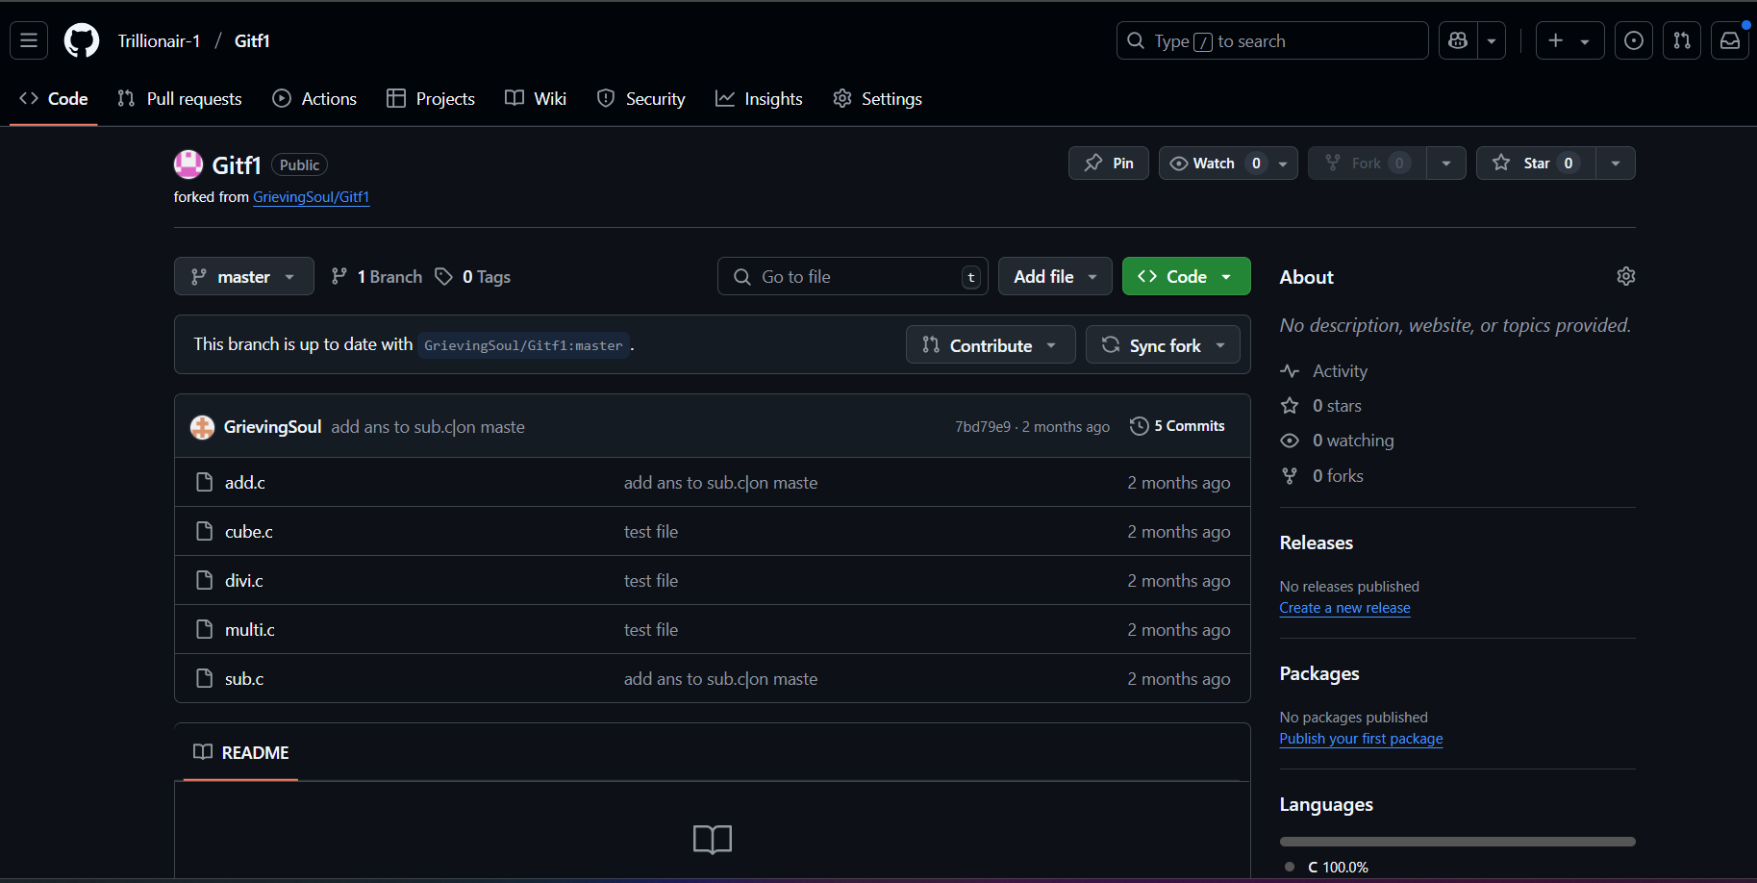

* **Now copy the URL of this forked repo.**
* **We will use the command “git clone” to clone the git repo into local repo.**

****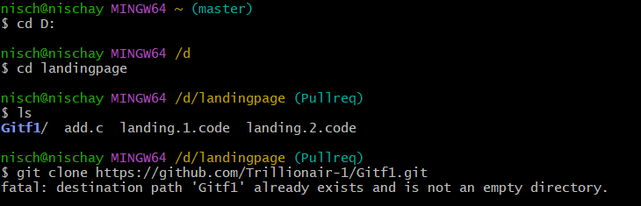

* **Then we will navigate into the forked repo, create a new branch , edit the file , commit and push it.**

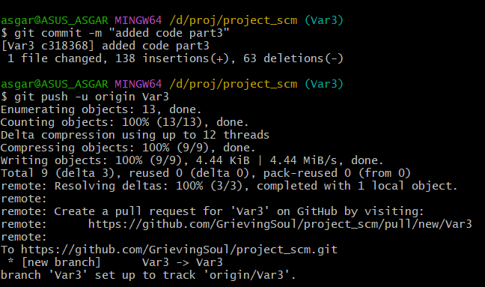

* 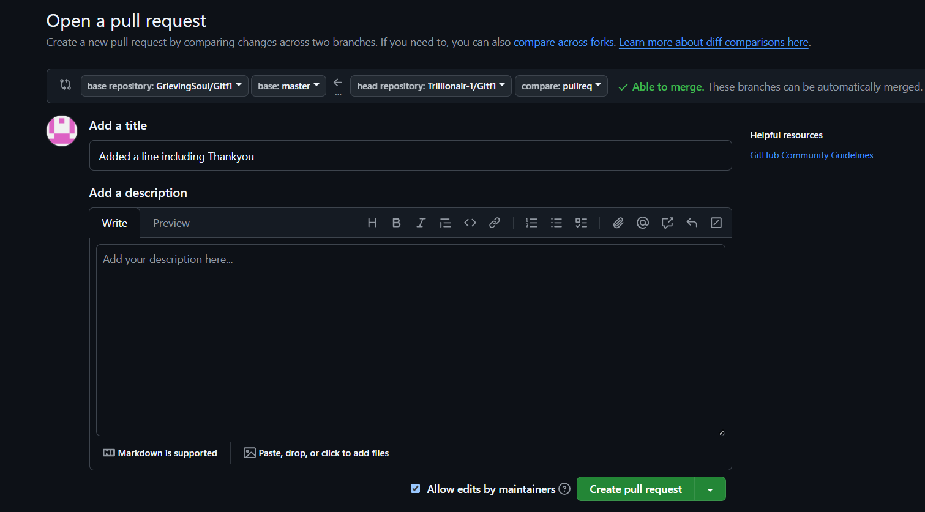**After pushing , go to the github and on top psnel there will be a “pull request” option. Click on it.**
* **The above page will open. Now select your base and head-repos, add comments if necessary and click on create pull request.**
* **After creating pull request this page will appear.**
* 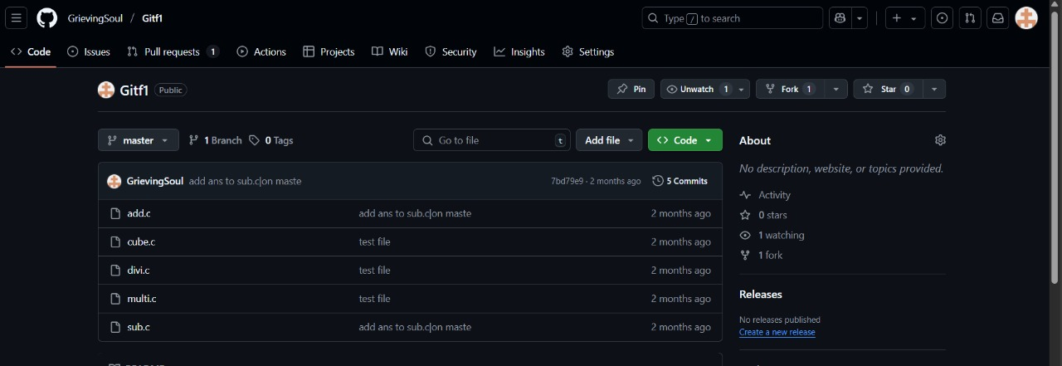**The receiver will have got a pull request notification.**
* **After clicking on it…**

* **After scrolling down the receiver will have an option of “merge and pull”.**

* **Click on that and close the pull request**
* **After clicking of merge and pull , edited code will get merged into the receivers repo.**
* **This is all about pull request.**

**THANK YOU**